PRIMARY REPORT - INFORMATION BASED CHATBOT

Specialization in research in digital of IT

Written by:
XYZ
Heartful Thanks to
XYZ (Chief Data Scientist and Technology Advisor)
XYZ (Director, Distinguished Data Scientist)
Team Members
XYZ, ABC, …..

Project of Content

- Introduction
  - Description

- Business Understanding
2.1 Business Objectives
2.2 Business Constraints

- Business Criteria
3.1 Business success criteria

- Economic Criteria

- Designs process and methods

- Process Architecture

- Modelling

- Evaluating the Chatbot

- Conclusion

- Introduction

A chatbot is software that simulates human-like conversations with users via text messages on chat. Its key task is to help users by providing answers to their questions. A chatbot is a type of software that can automate conversations and interact with people through messaging platforms. Our use case is to develop a chatbot that can answer Machine learning and Artificial Intelligence questions asked by students.

  - Description

In our Project we explore how a chatbot can give the information to the students. In the first iteration of the project we created a chatbot for giving information as Questioning. In the second iteration we wanted to explore the use of the chatbots through theory and used this in combination with testing. In the final iteration, iteration three, we improved and changed the chatbot based on the results from the last iteration and made a plan for evaluate the chatbot. The plan was executing with 8 participants. In our conclusion we discuss the results from the evaluation in the light of our research question.

- Business Understanding

2.1 Business Objective

- Maximize the doubt clarification for the students
- Maximize the tendency to answer questions.
- Maximize the time and human presences to clarify the doubts.

  - Business Constraints

- Minimize the time to answer
- Minimize the handling large documents collections.

- Business Criteria

3.1 Business Success Criteria

To develop the project used the AI chatbot or Questioning – Answering system (CDQA) and automatically answer questions posed by humans in a natural language.

- Economic Success Criteria

- This system helps to reduce the human presences.
- This helps the students to get the doubts clarification immediately and reduces the time consumption for the information or subject.

- Design Process and Methods

For the project, we wanted to build the chatbots using QA systems. It can be an Open domain QA system or closed domain QA system. Our model has a specific domain CdQA, haystack and Behavior Analytics is the appropriate system to implement.

Working Model: Haystack and CDQA

Haystack is an end-to-end framework that enables you to build powerful and production-ready pipelines for different search use cases. Whether you want to perform Question Answering or semantic document search, you can use the State-of-the-Art NLP models in Haystack to provide unique search experiences and allow your users to query in natural language. Haystack is built in a modular fashion so that you can combine the best technology from other open-source

Closed-domain systems deal with questions under a specific domain and can exploit domain-specific knowledge by using a model that is fitted to a unique-domain database. The cdQA-suite was built to enable anyone who wants to build a closed-domain QA system easily.

- Process Architecture

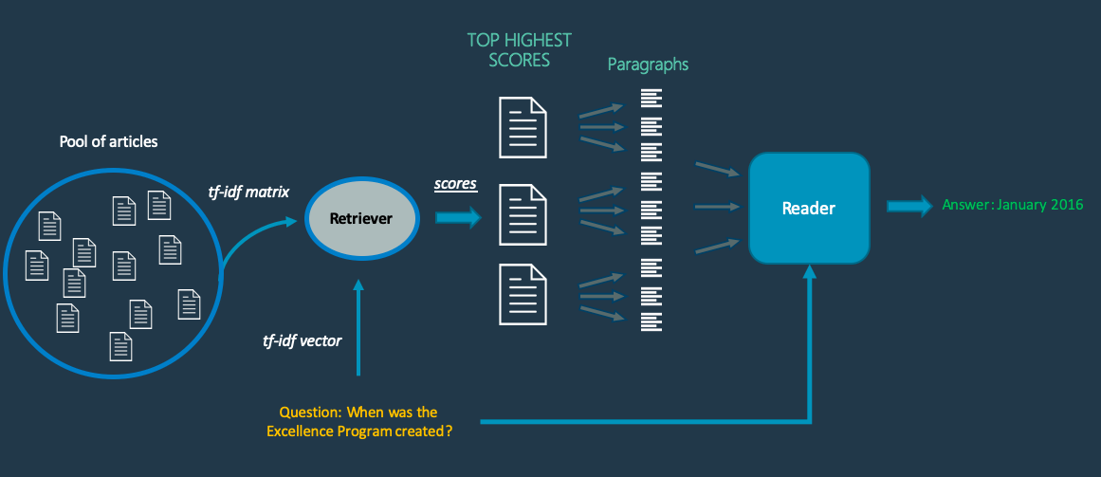

- Modelling

The cdQA architecture is based on two main components: the Retriever and the Reader.

Retriever:

When a question is sent to the system, the Retriever selects a list of documents in the database that are the most likely to contain the answer. It is based on the same retriever of DrQA, which creates TF-IDF features based on uni-grams and bi-grams and compute the cosine similarity between the question sentence and each document of the database.

Reader:

After selecting the most probable documents, the system divides each document into paragraphs and send them with the question to the Reader, which is basically a pre-trained Deep Learning model. The model used was the Pytorch version of the well-known NLP model BERT, which was made available by HuggingFace. Then, the Reader outputs the most probable answer it can find in each paragraph. After the Reader, there is a final layer in the system that compares the answers by using an internal score function and outputs the most likely one according to the scores.

Fine-tuning model:

Once training data is collected, you can fine-tune your base models. Initialize a reader as a base model and fine-tune it on our own custom dataset (should be in SQuAD-like format).

Pipelines:

In order to build modern search pipelines, you need two things: powerful building blocks and a flexible way to stick them together. The Pipeline class is exactly build for this purpose and enables many search scenarios beyond QA. The core idea: you can build a Directed Acyclic Graph (DAG) where each node is one "building block" (Reader, Retriever, Generator ...).

Used Tools:

- Aws Sage maker
- Google Colab

- Evaluating the Chatbot

We wanted to evaluate the prototype in the right context, which for the questioning and answering. We listed a set of questions and tasks which we asked the students to answer and perform. We also included a few control questions to investigate the participants experience with the chatbot and to find out if they had any suggestions for further improvement. The evaluation ended with a short talk about the experience, where we were open for any kind of feedback the evaluators could provide.

- Discussion and conclusion

When testing the last prototype we got findings suggesting that the students did not have a problem with getting information from a chatbot instead of a human. The information that they got was not seen as less trustworthy, this could be supported by the fact that the chatbot provided a source for the information it gave. It has been interesting to investigate how the students interacted with the chatbot and how they reported on it afterwards. Our findings have some indicators leading towards that a chatbot could be a good alternative for acting as a helpful friend for freshmans at a new school. Still we have to stress the fact that the chatbot was not very intelligent and that the evaluators had to adjust their language to match the chatbots.
The scope of the project is save the human and time for the question and answering.

- Reference

Web reference: https://haystack.deepset.ai/docs/latest/retrievermd

Jung, M., Hinds, P., 2018. Robots in the Wild: A Time for More Robust Theories of
Human-Robot Interaction. ACM Trans. Hum.-Robot Interact. 7, 2:1–2:5.

Lazar, J., Feng, J. H., & Hochheiser, H. (2017). Research methods in human-computer
Interaction. Morgan Kaufmann.

